Area President: Martin Elliott email: swpresident@oga.org.uk
Area Secretary: David Patuck Chatsworth, Broadway, Ilminster Somerset TA19 9RG
Tel 01460 52088 mobile 07974 827469 email: swsec@oga.org.uk

Helford Rally 16th – 17th June
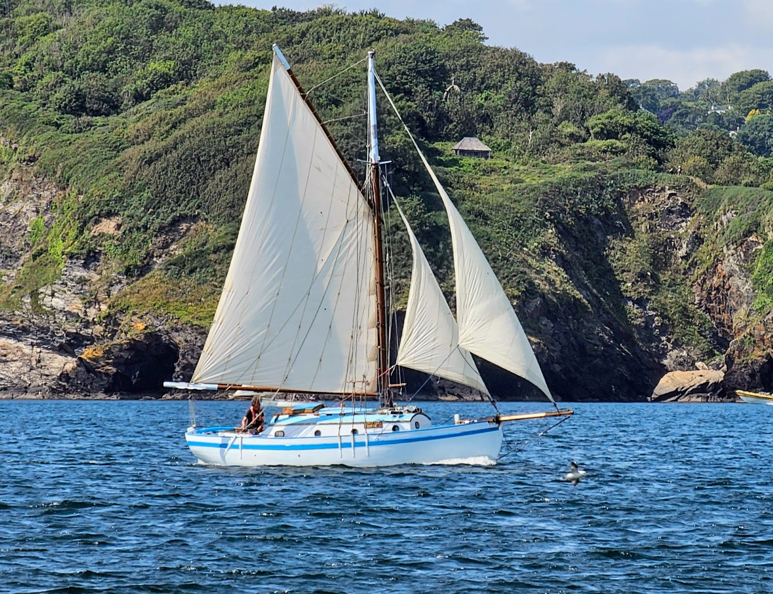
Following on from the Falmouth Classics 12th – 15th June, sail across Falmouth Bay to the beautiful Helford River.

Programme

16th June Arrival – Moor on the visitors moorings. £20.00 / boat/night (under 30’LOD). Please fly OGA flag, if possible, so Ian, the moorings officer, can identify a mooring for you and not charge you directly.

18.30 Barbecue on Pedn Billy Beach east of the boat house (north bank). LWT 2102 BST. Bring your own food and drinks. Barbecue, salad and puddings are provided.

17th June 12.00 Race – cruisers in Falmouth Bay and open boats in the river. HWT 1002 BST. Picotee (above) will probably act as committee boat.

Evening 18.30 prize giving followed by dinner at the Port Navas Yacht Club. LWT 1627 BST. There will be water (just) on the end of the pontoon throughout.

18th June Depart

Port Navas Yacht Club Prizegiving Dinner – Tuesday 17th June

Please complete & return the proforma below to timpriceabroad@hotmail.com by Sun 08 June 2025

MENU for Meal:
Starters | No Required
Ham hock terrine, parsley-pickled shallot salad, baguette
Spanish tomato salad with shaved goat’s cheese and rocket
Mains
Cornfed chicken breast, rosemary & garlic-sautéed potatoes, porcini mushroom sauce and green beans
Vegetarian option: Seasonal ravioli (will be confirmed nearer the date) but for example - asparagus, wild garlic and ricotta ravioli with Parmesan, lemon oil and pine nuts.
Puds
Chocolate mousse, whipped cream, strawberries and praline
2 Courses = £26.00 PP or 3 Courses = £34.00 PP
Your Name: No for meal: Meal Total:
RACE ENTRY:
Boat’s Name:
Length (LOD): Sail No/id: OGA T(H)CF) if known :
MOORING for 1 or 2 nights? Yes / No Mooring Total:
(£20 per night per boat (under 30’ LOD) rafting likely)
ENTRY FEE for race prizes & barbecue incidentals £14 per boat:  (The SW Area are also subsidising the prizegiving supper.) | £14.00
£ TOTAL TO PAY:
£26.00 PP - 2 Courses £34.00 PP - 3 Courses + 1x Entry + 1x Mooring = Total
Payment of £…………… has been made, by BACS / Faster Payment to: Y/N
South West Gaffers (Metro Bank)
Sort Code 23-05-80
A/C No. 40530002. Please add Reference: “Helford“
Please make your payment on line and return completed form, by email, to:
Tim Price, timpriceabroad@hotmail.com by Sunday 8th June

