OGA 2025 Photographic Competition
The Winners - Judged by Charles Erb

Category: - Life at Sea
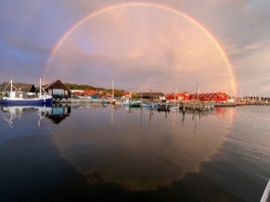
Highly Commended:

magic a-round Rik Janssen
(Dublin Bay, lives in Netherlands!)

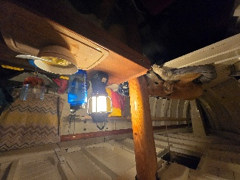

Home where the heart is Martin Braint (Solent Area)

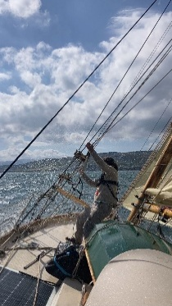

Nee aboard Sender Brian Duff * (Maryland, USA)

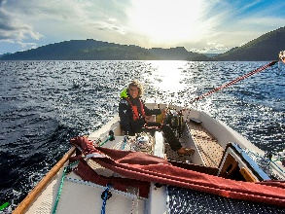

Champagne Sailing Gerard Brown (East Coast)

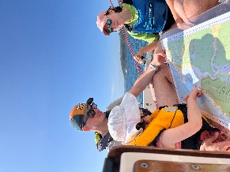
Third place:
Plotting a fix Paul Hardy (South West Area)

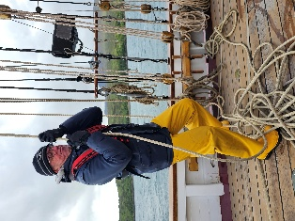
Second place:
Raising the trysail Mary Gibbs (North Wales Area)

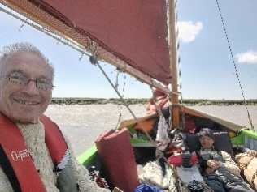

First place:
After Lunch rest! Alasdair Mackenzie (East Coast Area)

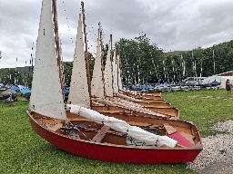
Category: - The Boats

Highly commended:
Gaffling Gaffle, Chris Stanger (North West Area)

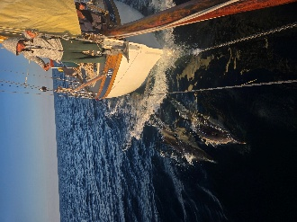

Smotoring on Sender Brian Duff * (Maryland, USA)

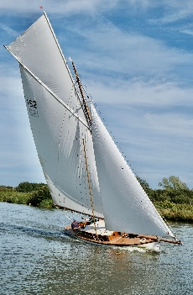

Old Gaffers Weekend Chris Rushton (North West Area)

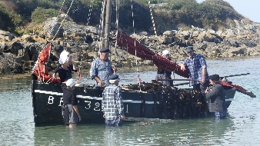

Third place:
Unloading seaweed Edgar Wagemakers (East Coast Area)

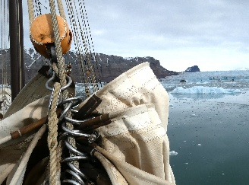

Second place:
Glacier anchorage Claudia Myatt (East Coast Area)

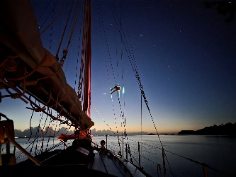

First place:
Keep the night Loic Le Marchand (Bretagne, France)

Only those highlighted in yellow have booked to attend the AGM, as of Jan 18
* Note that Brian Duff was a paid-up member in 2025, the year of the competition, but as of Jan 18 has not paid for 2026.

Colin Stroud, Association Secretary, January 28, 2026

