Area President: Martin Elliott email: swpresident@oga.org.uk
Area Secretary: David Patuck Chatsworth, Broadway, Ilminster Somerset TA19 9RG
Tel 01460 52088 mobile 07974 827469 email: swsec@oga.org.uk

Helford Rally 15th – 16th June
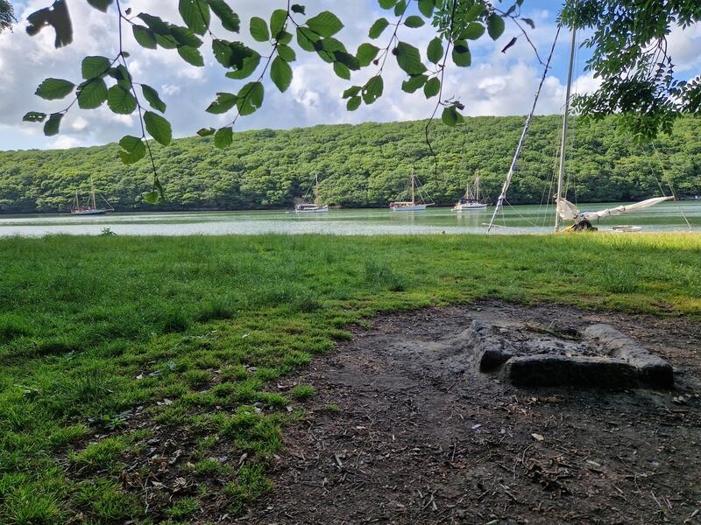
Following on from the Falmouth Classics 11th – 14th June, sail across Falmouth Bay to the beautiful Helford River. Last minute updates can be followed on the SW Gaffers WhatsApp Group.

PROGRAMME:

15th June Arrival – Moor on the visitors moorings or upriver at the pool at Tremayne Quay. We will receive preferential rates of £21 per boat per night (under 30’LOD) and the moorings officer will be on hand to identify moorings. You may need to raft to boats of a similar size.

18:00 Barbecue on Tremayne Quay. HW 19:10 BST (5.2m). Bring your own food to grill and drinks and also plates and cutlery. Barbecue, salad and puddings are provided but please make us aware of allergies and intolerances.

16th June 13:00 Race – cruisers in Falmouth Bay and open boats in the river. LW 14:27 BST (0.5). Picotee will probably act as committee boat.

Evening 18:30 prize giving followed by dinner at the Helford River Sailing Club. HW 1910 BST (5.2m). There will be water on the end of the pontoons throughout.

18th June Depart (if arriving earlier or staying longer - normal visitor mooring rates will apply)

Moorings discounted by Helford River Moorings £21.00 per boat per night (up to 30’ LOD). Fees are to be paid in advance (or in cash during event).

Helford River Sailing Club Prizegiving Dinner – Tuesday 16th June 2026

Please complete & return the form below to timpriceabroad@hotmail.com by FRI 5th JUNE 2026

Starters | No Required
Prawn pil pil, garlic ciabatta
Crispy chicken wings, buffalo sauce, ranch dip
Mushroom and onion croquette, aioli, leaves - Vegetarian
Mains
Fish and chips, peas, tartar sauce
Double cheeseburger, gherkins, onions, burger sauce, chips
Massaman curry, basmati rice - Vegetarian
Puds – Both Vegetarian
Sticky toffee pudding, toffee sauce, Roskilly’s vanilla ice cream
Lemon posset, raspberry coulis
Any Allergies or intolerances (Please let Tim know) Y/N:
£27.00 - 2 Courses. £32.00 - 3 Courses (with SW OGA subsidy) MEAL TOTAL :
Race Entry – BOAT’s NAME:
Length (LOD): Sail No/id: OGA T(H)CF) if known :
SKIPPER’s NAME: SKIPPER’s MOBILE:
I agree to being added to What’sApp Group - Y/N :
Mooring - up to 2 Nights. No required x £21.00 MOORING TOTAL:
Prizes, BBQ & Incidentals, - PER BOAT (group, if no boat) ENTRY FEE: | £14.00
GRAND TOTAL: | £
Payment of £…………… has been made, by BACS / Faster Payment to:
South West Gaffers Nat West Bank
Sort Code: 52-30-42 Account number: 38129698
Please add Reference: Helford
If you wish to crew on another boat, or can offer space to crew on yours, please let us know, so that we can make arrangements for you.

